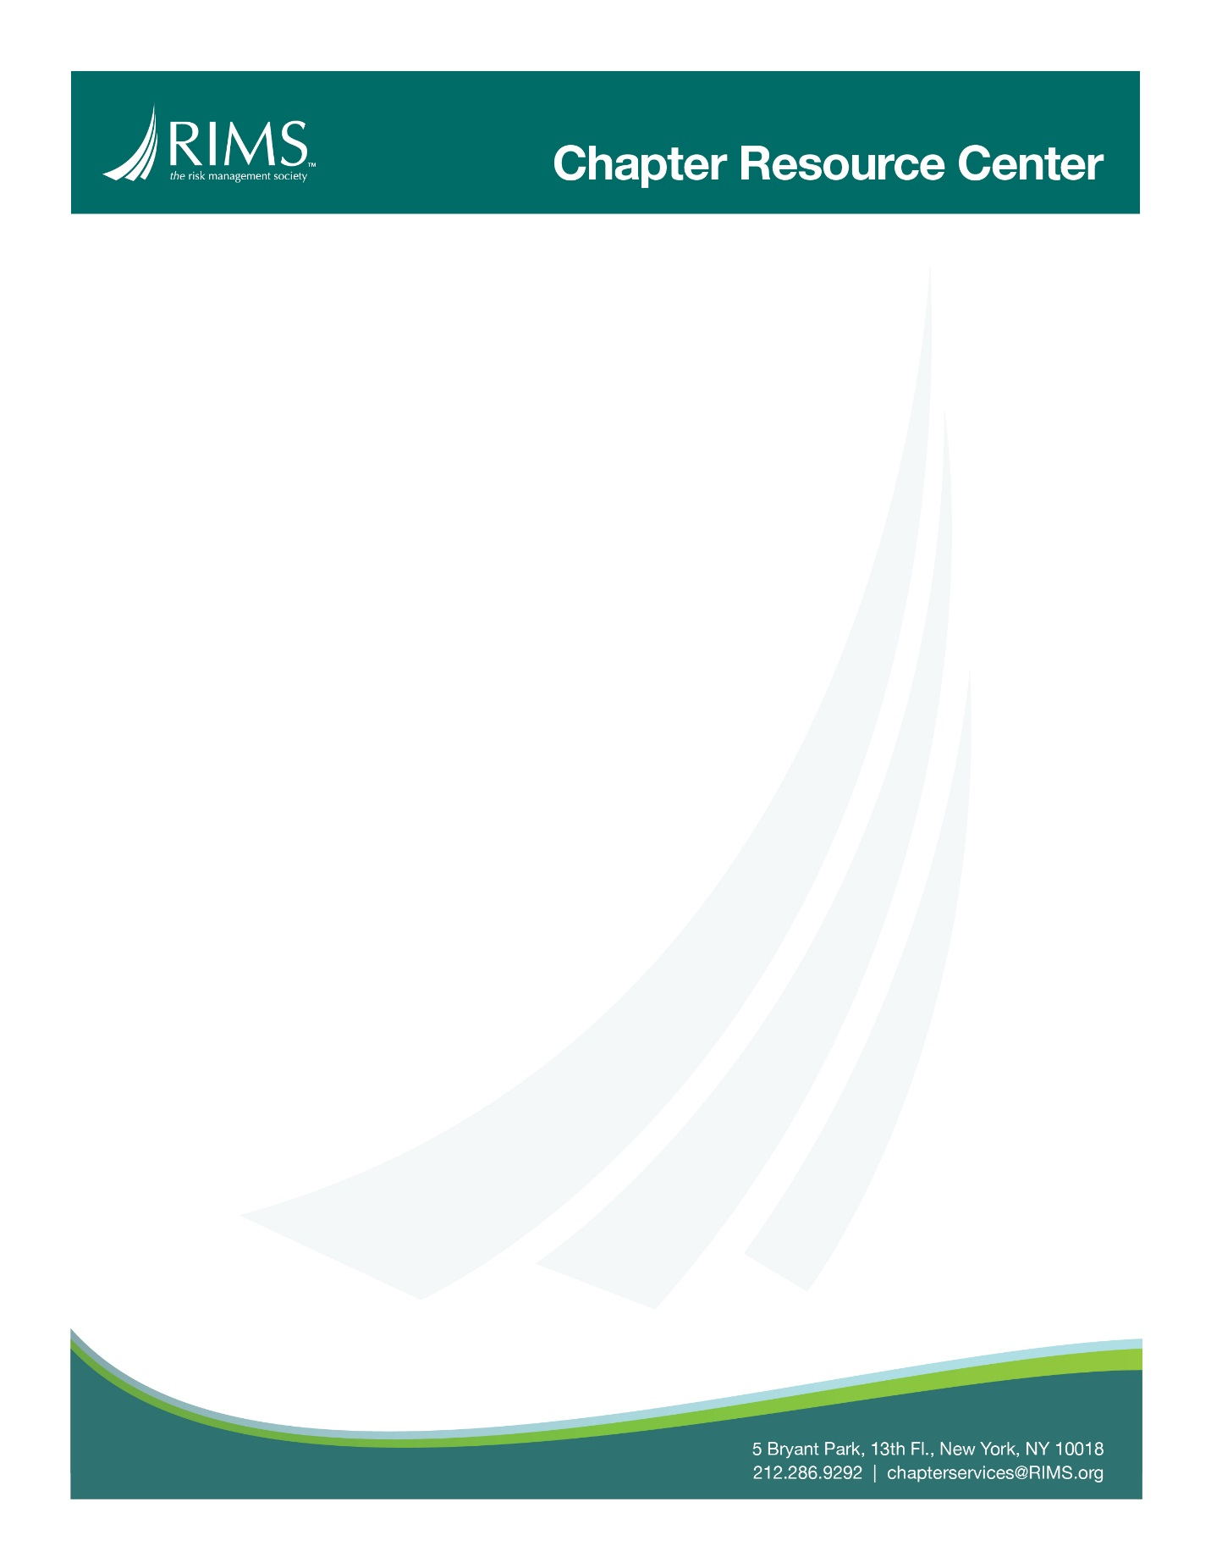

Chapter Email Templates – Expiring Members
It’s that time of year, time to renew your RIMS membership!
For more than 11,000 risk management professionals, RIMS means Learning, Resources and Connections. Don’t let your benefits expire. Renew your membership and continue your access to:
Active Community
• [Insert Chapter] for in-person, local networking
• Our volunteer opportunities will help build your network and enhance leadership skills
Education At All Levels:
• RIMS offers a variety educational offerings including webcasts, online courses and in-person workshops.
• RIMS brings together a global audience of risk professionals at several events throughout the year, delivering nearly 200 educational
Industry-Leading Content
• Risk Knowledge is a searchable library of executive reports, white papers, survey findings, articles, industry research and more that provides the most detailed information on a wide variety of topics.
• Risk Management magazine includes insight and analysis on trends and emerging techniques and concepts.
• RiskWire, our twice-weekly news service, is delivered right to your inbox.
Innovative Resources
• Opis is a new way for RIMS members to access content, exchange information, collaborate and strengthen skills. This smart technology delivers customized content recommendations based on one's personal competencies, skills and interests.
• RIMS Marketplace is the most comprehensive directory of solutions providers and includes free content for risk professionals.
• The Strategic and Enterprise Risk Center is a dedicated web portal that provides you with knowledge, tools and resources to support your strategic and enterprise risk management efforts.
• The RIMS Benchmark Survey is a single source of benchmark statistics with industry data from over 52,000 insurance programs.
We want to see you at the next Chapter meeting. Renew your membership online today! We've made it as easy as possible for you to renew online.

If you wish to renew your membership or make changes, please contact cst@rims.org or call 212-655-9292 (select prompt #1).
We look forward to continuing to serve you.
Kind regards,
[Chapter Leader]

