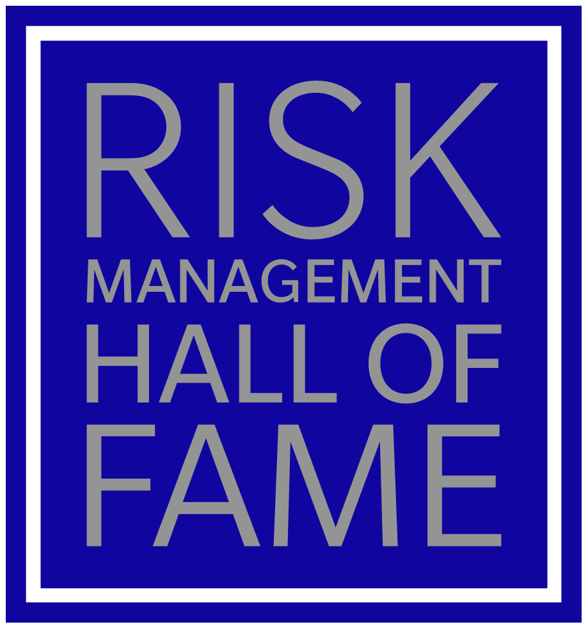

NOMINATION FORM
Submission Deadline: February 29, 2024

Email all entries to: JSALTER@RIMS.ORG

RISK MANAGEMENT HALL OF FAME NOMINATION FORM

Information about the Nominee:
Name of Nominee
Last Employer
Title at Last Employer
Designations/Certifications Held
Address
Telephone
E-mail

Nominees age:

Under 65 Over 65 Deceased

Number of Years Retired:

Less than three years More than three years

Number of Years in Risk Management, Insurance, ERM, Strategic Risk Management:

0 – 10 years 11 – 20 years 20+ years

Number of Years as a RIMS Member:

0 – 9 years 10 – 20 years 20+ years

Information about the Nominator:
Submitted By (Name)
Company/Organization
Title
Telephone
Email

CAREER SUMMARY/HIGHLIGHTS:

The following questions will help the Risk Management Hall of Fame (RMHF) Selection Committee efficiently review the success and achievements of the nominee specifically the contributions the individual has made to advance the risk management discipline.

Acted as a Risk Management Educator / Mentor | Yes / No | Where / Topic  1.  2.  3.
Lectured at Conferences | Yes / No | Where / Topic  1.  2.  3.
Risk Management / RIMS Volunteer Work | Yes / No | Volunteer Work / Position Held  1.  2.  3.
Published Articles / Reports | Yes / No | Publication / Title or Topic  1.  2.  3.
Involvement in Other Risk Management Associations/Organizations | Yes / No | Association / Title  1.  2.  3.
Community Involvement | Yes / No | 1.  2.  3.

ADDITIONAL PROFESSIONAL HIGHLIGHTS:

How has the nominee contributed to risk management, enterprise risk management and/or strategic risk management and inspired others to either pursue careers in this industry or advance the profile of their organization’s risk management program?

CAREER RECOMMENDATIONS:

Recommendations can be provided by colleagues and other risk management professionals who can articulate the nominee’s contribution to the risk management profession including the impact the nominee has had on risk management. Please include a minimum of two and no more than five recommendations.

PLEASE SUBMIT THE FOLLOWING MATERIALS UNDER SEPARATE COVER:

- Nominees professional bio (if available).
- Headshot. A hi-res jpeg (1MB or larger) of the candidate suitable for reproduction or if the candidate is deceased the most recent photograph available
- Supporting material, e.g. magazine/newspaper articles, certificates, historical records, letters, videos,etc. (if available).

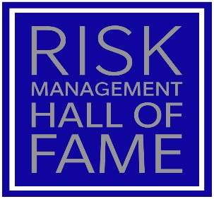

RISK MANAGEMENT HALL OF FAME

Founded in 2011, the Risk Management Hall of Fame (RMHF) was established to maintain the history and tradition of the field of risk management, and serves as a means to recognize and commemorate those professionals who have made significant contributions to advancing the discipline.

New members to the Risk Management Hall of Fame are announced yearly at RISKWORLD®, RIMS annual conference and exhibition.

PURPOSE
The RMHF has been organized to maintain the history and tradition of the field of risk management. It serves as a vehicle to recognize, preserve and honor leaders in risk management who have made significant contributions to advancing the discipline. The Hall of Fame acknowledges the services and accomplishments of the individuals to their employer, their peers and the discipline in general and the indelibility of his/her impact.

ELIGIBILITY
Nominees will be considered among risk management professionals around the globe. Criteria considered by the Selection Committee for membership in the RMHF will include considerable contributions to the field; prominent achievements, innovation and trend setting; demonstrated leadership, character and service; and the highest caliber of ethical and professional conduct.

Nominees must have been a member of RIMS for at least 10 years. The nominee must be retired as a practicing risk manager at least three years prior to nomination. In the event that an active risk manager dies and otherwise meets the criteria, they will be qualified for consideration at the time of their death. The deadline for submission is January 29, 2021.

